**POWER BI ASSIGNMENT-6**

**Use Case -** DAX Measure

**Source –** LifeScience

**Analytics –** DAX Groupings

**Requirement**

1. Create the following segment in terms of purchase
2. Affordable(if <10)
3. Expensive(if >10)

Step-1: Using DAX Function, We can find it

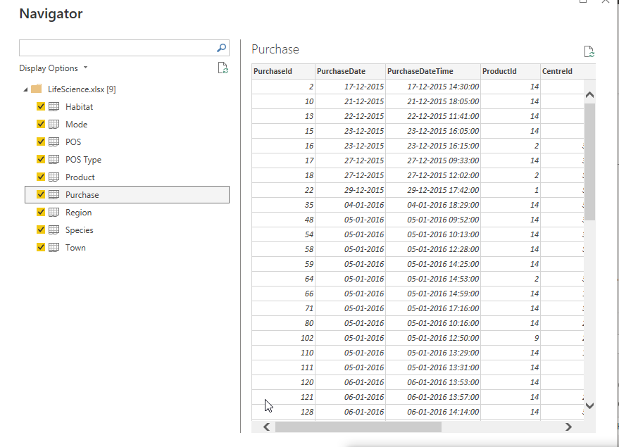

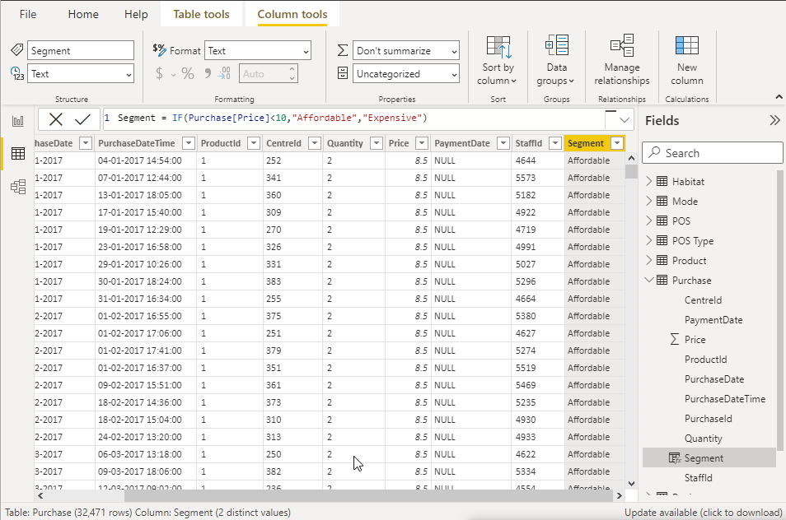

1. Need a report on the quantities available on the basis of animal
2. Affordable
3. Expensive

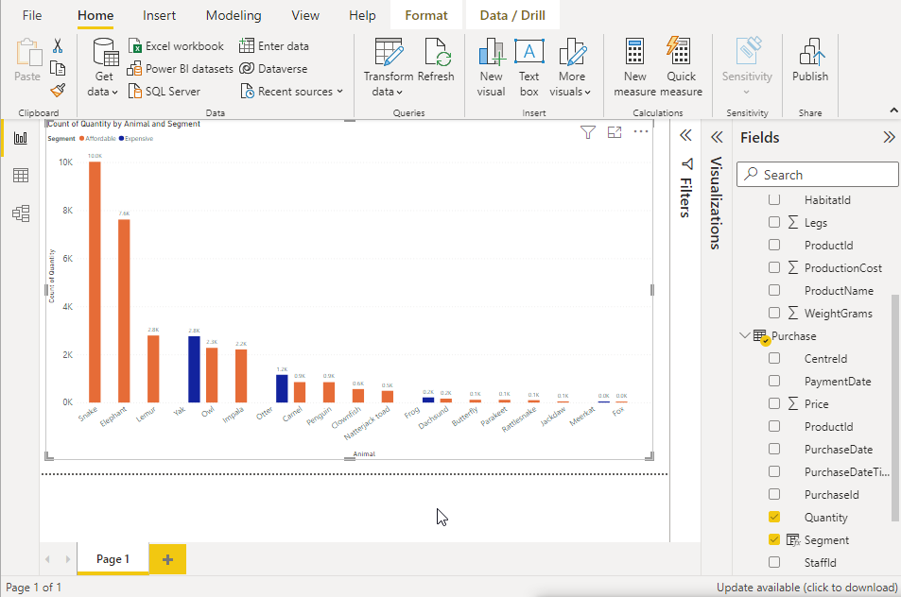

1. Need to know how many animals do not belong to Air, Water and Land

Step-2: Using DAX calculate function we can execute the steps

Not Land = CALCULATE(COUNT(Habitant[EnvironmentId]), Habitant[EnvironmentId]<>1)

Not Air = CALCULATE(COUNT(Habitant[EnvironmentId]), Habitant[EnvironmentId]<>2)

Not water = CALCULATE(COUNT(Habitant[EnvironmentId]), Habitant[EnvironmentId]<>3)

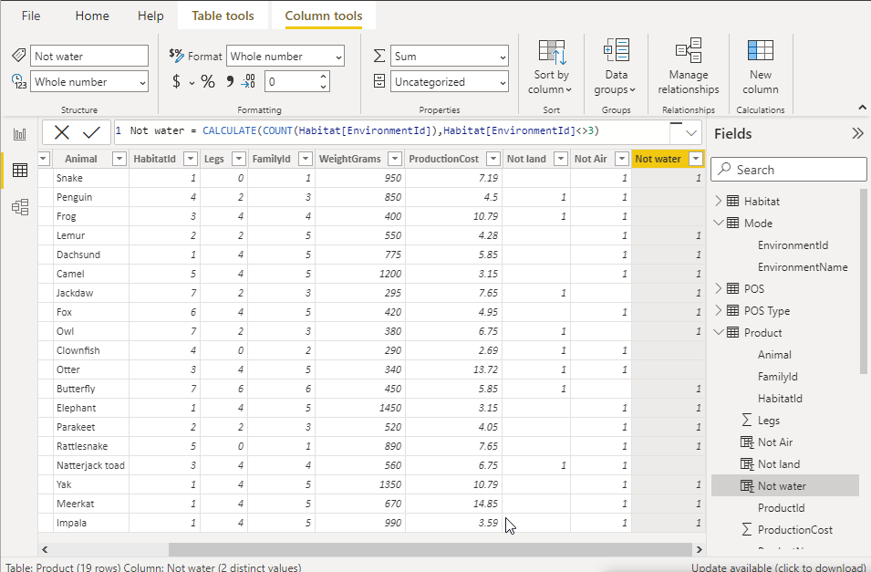

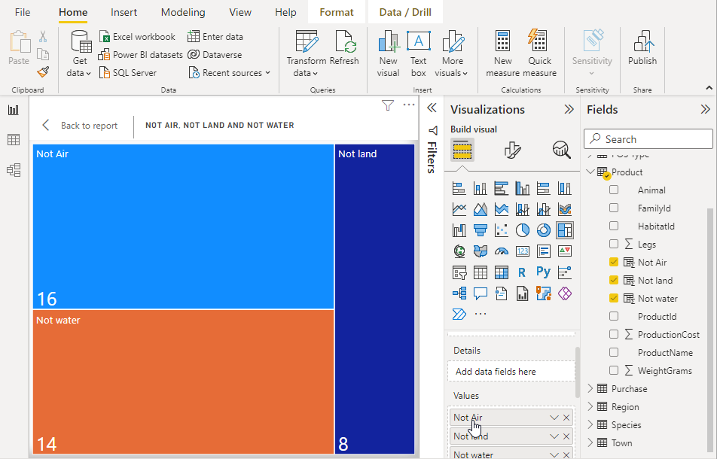

1. Create a Segment on the basic of Species By referring Animals and create a column in the required table.(hint- Product Table)

Step- 3. Species = RELATED(species[FamilyName])

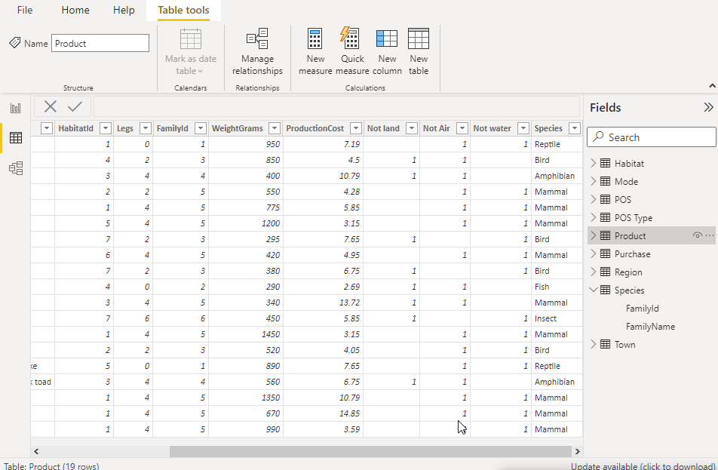

1. Need to segment the towns on the basis of region.

Step – 4. Region = RELATED(Region[RegionName])

